USER MANUAL

Bus Algorithm Tool

Julien Vossen, Anastasia Dmitrieva, Litta Plant, João Formigo
Applied Mathematics, Fontys Technology

Table of contents

1. Introduction 3
2. Preparing the Input files 3
3. Checking the excel file formatting 5
4. Preparation 6
5. Feasibility check 9
5.1 Time Feasibility 9
5.2 Location Feasibility 9
5.3 Energy Feasibility 9
5.4 Data requirements 9
6. Running the algorithm 10
7. Viewing the Visualization 12
8. Comparing the KPI's 13
9. Downloading the output in excel-format 15

1. Introduction
This tool is designed to optimize the planning of buses that take part in bus lines 400 and 401 for the company Transdev. It is also able to compare two different plannings in terms of the number of buses, the total idle time where buses are standing still and the total energy consumption.
The target users for this tool are people responsible for planning and scheduling. No programming knowledge is required to use the tool.

2. Preparing the Input files
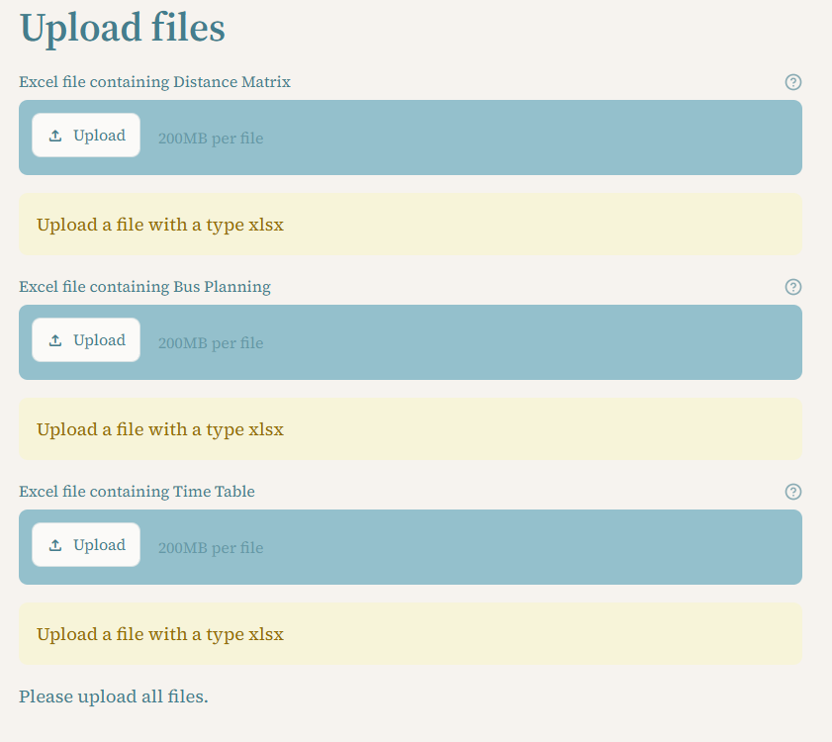
Before using the tool, make sure that all required Excel files are correct and in working order.
Figure 1. Upload buttons for Excel files.
The tool uses the following input files:
- DistanceMatrix.xlsx
- Bus Planning.xlsx
- Timetable.xlsx
And these files are to be put in their corresponding upload bars. What file to upload and in which box can be seen right above each upload bar as shown in Figure 1.

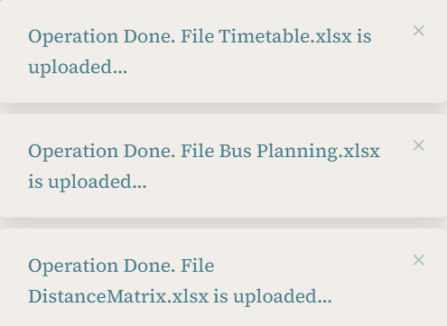
Once uploading a file, you will see its short version and get a notification that the action has been done successfully as you can see in Figure 2. 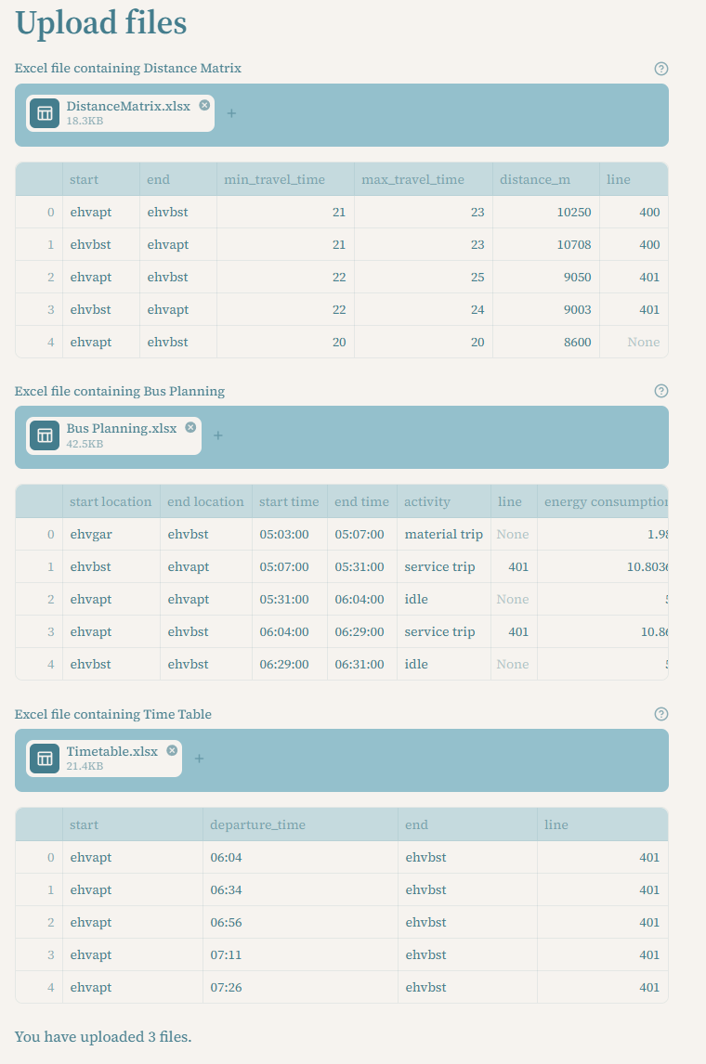
Figure 2. Showcase output after uploading the correct files.

3. Checking the excel file formatting
Column name | Description | Format | Example
energy consumption | How much energy is used | Number | 10.85
bus | Identification of the bus | Integer | 12
start time | The starting time of an activity | HH:MM:SS | 15:00:00
end time | The time when an activity ends | HH:MM:SS | 15:30:00
start location | The location where an activity starts | Text | ehvbst
end location | The location where an activity ends | Text | ehvapt
line | States what bus line is being used in an activity | Integer | 401
activity | States the type of activity that is being done | Text | service trip
Table 1. Required excel formats.

4. Preparation
Below the files you can find the button for checking files as shown in Figure 3. This button cleans the uploaded bus plan for missing columns, incorrect name, invalid times, duplicated rows, energy consumption and idle activities that have no idle time.
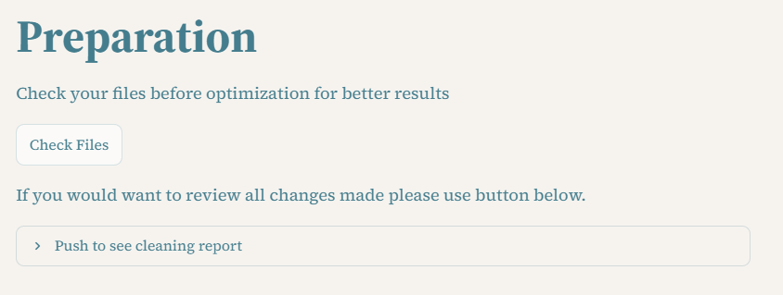
Figure 3. Picture of the preparation and cleaning report.

After pressing the check files button, you will get a short display of the excel files, which have been checked for possible mistakes as shown in Figure 4.
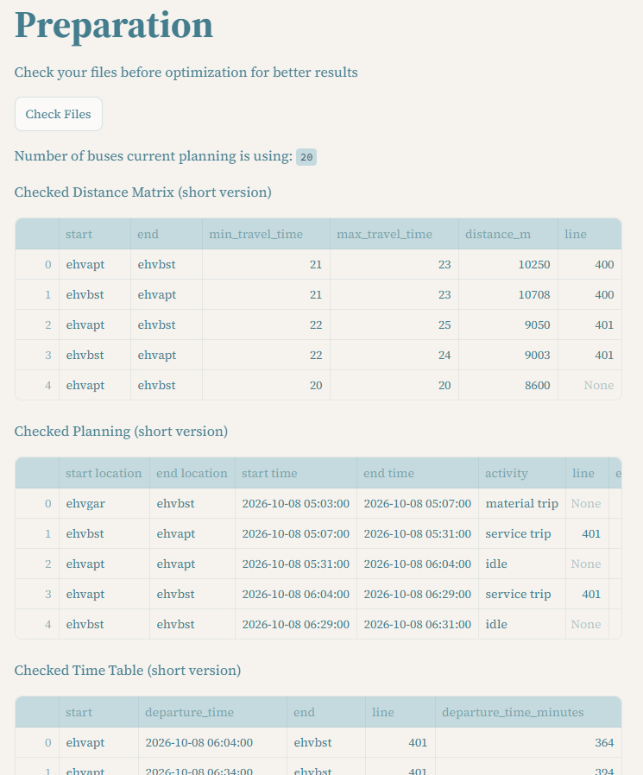
Figure 4. How your files should be displayed after using Check files button.

Below the short versions of the excel files you can find a report of the changes that were made after the original excel files were reviewed (Figure 5).
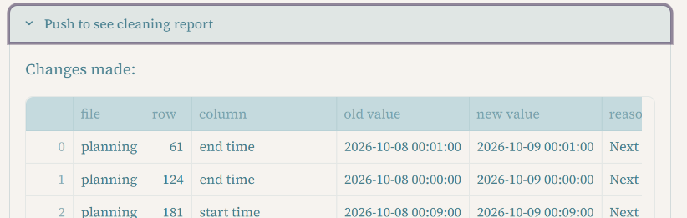
Figure 5. Cleaning report.

5. Feasibility check
After running the check files button, the data has also been checked for feasibility. The report with possible issues found can be seen under ‘Issues found’ heading in cleaning report section. The feasibility check can give a multitude of error outputs, which are described as follows:

5.1 Time Feasibility
• Activity invalid: Start or end time is missing or is earlier and/or equal to the start time.
• Overlapping activities: Activities of the same bus overlap each other.

5.2 Location Feasibility
• Problem with location: The start location of a bus does not correspond with the end location of the previous activity.
• Idle or charging at different locations: One idle or charging activity has different starting and end locations.
• Trip has the same location: One material or service trip has the same starting and end location.
• First trip is not material: The first trip must be a material trip from "ehvgar''.
• Charges outside of the garage: A bus is only allowed to charge at "ehvgar".
• Bus does not return to the garage: A bus must return to "ehvgar" at the end of its planning.

5.3 Energy Feasibility
• Energy missing: Energy consumption is missing.
• While charging needs to be negative: Energy while charging a bus must be negative, because the battery is receiving energy.
• Charging time less than 15 minutes: A charging activity must be at least 15 minutes long.
• Charging energy calculation: The registered charging energy must be the same as the calculated charging energy based on 450kW.
• Energy is wrong, it is not charging: Normal activities may not have negative energy consumption.
• Battery is below 27 kWh: The battery of a given bus must not be below the minimum capacity of 27 kWh.

5.4 Data requirements
• Missing columns: Checks if all required columns are in the input files, including: 'bus', 'end location', 'start location', 'activity', 'energy consumption'.

6. Running the algorithm
Once the data cleaning and feasibility checks have been completed, click the Optimize button to generate an optimized bus planning (Figure 6).
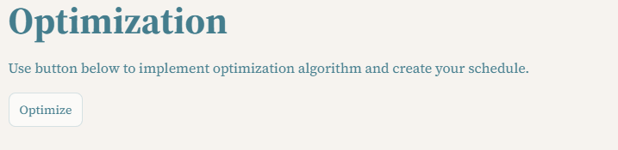
Figure 6. Optimization button.
After running the optimize button, the schedule will mention the number of buses in the optimized schedule and will now allow you to create a visualization for the new schedule as seen in Figure 7.
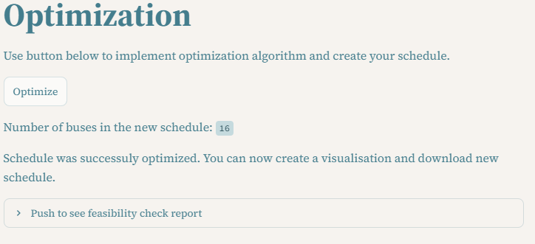
Figure 7. The output after successfully running an optimization.

The final addition to the optimization is a feasibility check report of the algorithm, which is shown in Figure 8. Here you can see any final changes made regarding feasibility.
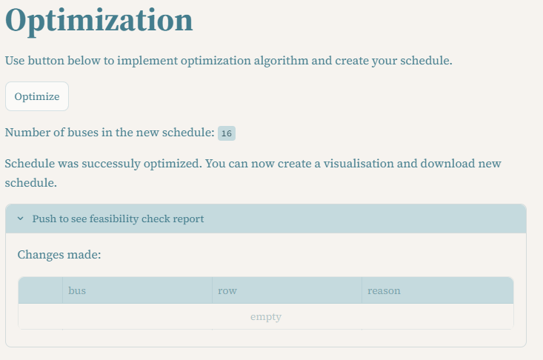
Figure 8. Feasibility check report.

7. Viewing the Visualization
When the algorithm has been run and an optimized schedule has been successfully generated, then you can find a button for a visualization of the improved bus planning (Figure 9).

Figure 9. Button for visualization.
This button generates a Gantt chart, which shows buses on the y-axis with time on the x-axis. This allows you to see what each bus used in the planning is doing throughout the full day. Furthermore, you can also see that the type of activity is clearly defined through a legend that explains what each color means (Figure 10, Figure 11).
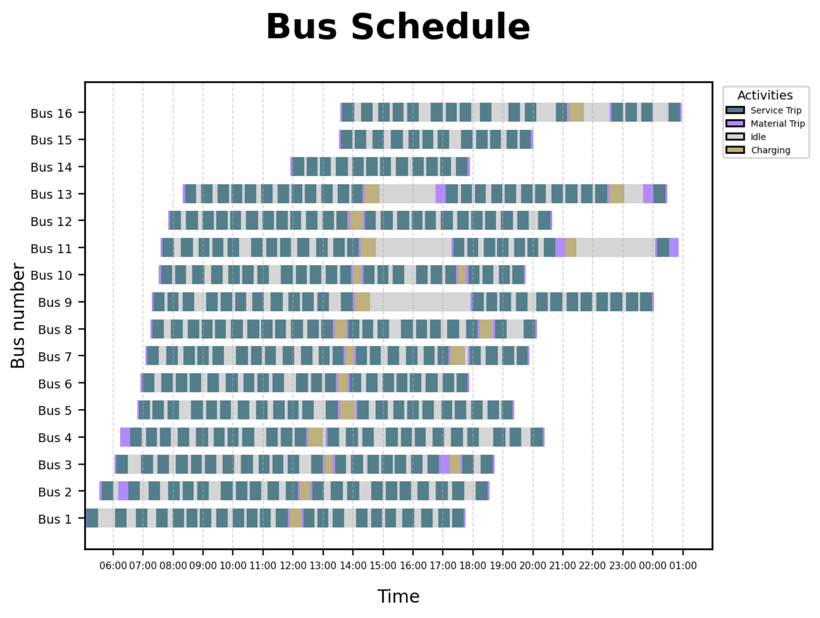
Figure 10. Example output of Gantt chart visualization.

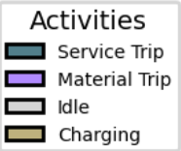
Figure 11. Legend of said Gantt chart.

8. Comparing the KPI's
You may find the KPI's which compare different aspects of the original planning and the planning that was constructed from the algorithm on the left-side bar of the tool. Make sure to have gone through chapters 2 - 6, described in this manual before trying to look at the KPI's.
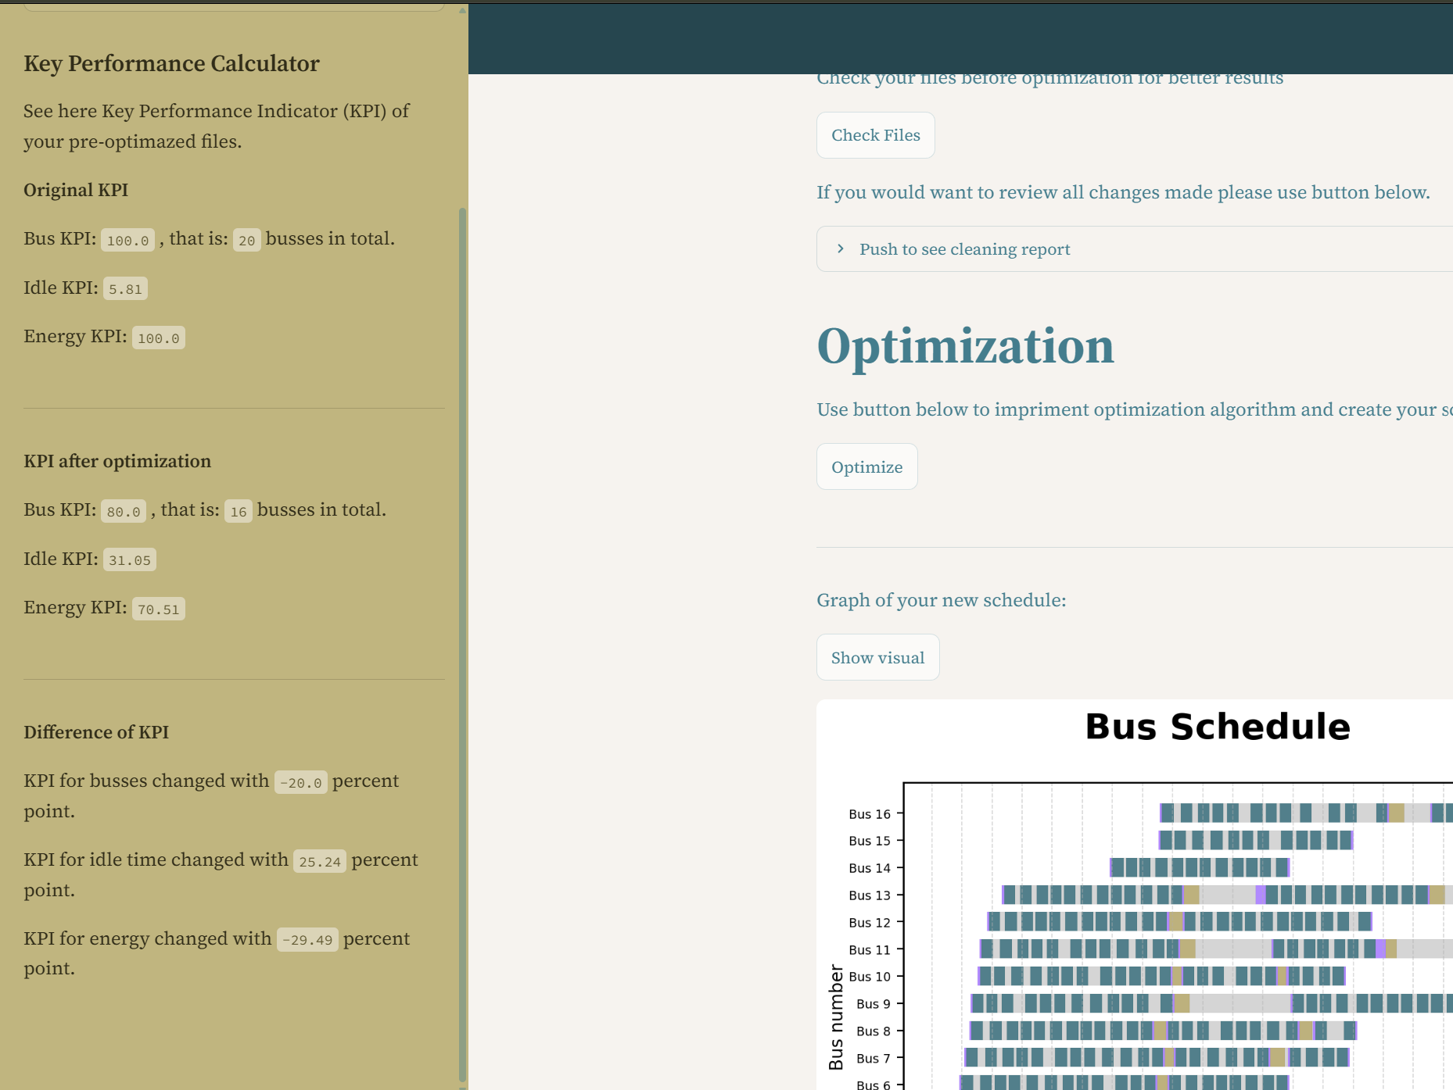
Figure 12. Display of what KPI's could look like.
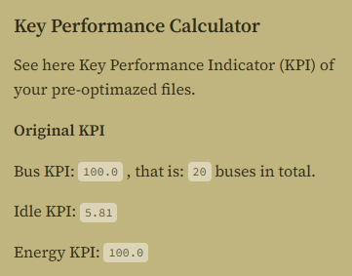
Figure 13. Original KPI output.
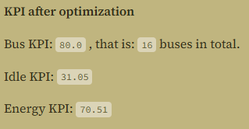
Figure 14. Output after optimization.
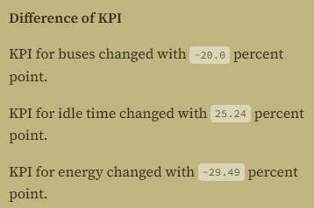
Figure 15. Output of the differences in KPI between the input and optimized schedule.

9. Downloading the output in excel-format

After chapters 2 – 6 have been completed, the user can click on the download button to export the generated optimized bus planning to an Excel file. The file exported contains all the required information about the new planning, which allows the user to review and use it for practical purposes. Finally, the user will receive a notification if the file has been downloaded successfully.
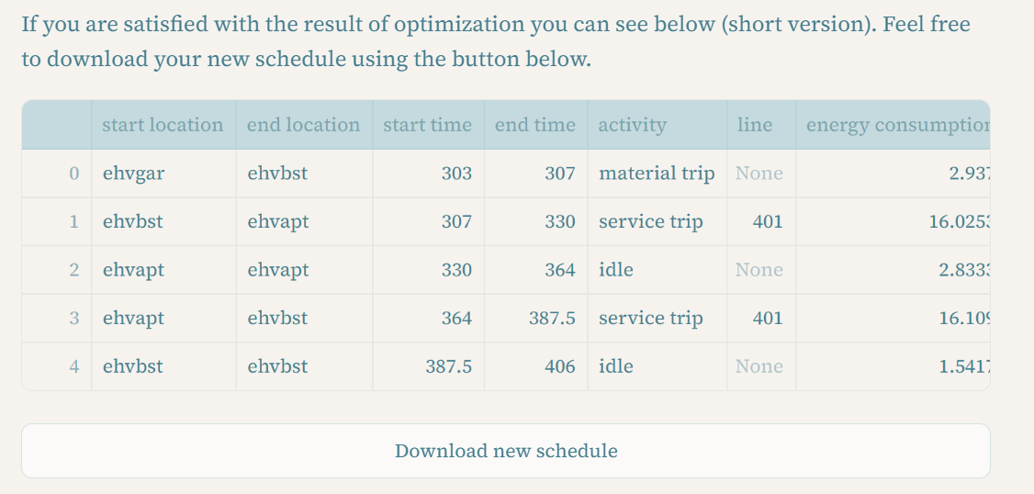
Figure 16. Button to download the optimized schedule.

